Match each term to the most appropriate concept. Not all terms are used. (2 pts each)

allopaternal care
atrium
buccal forcing
bulbous arteriosus
classification
conus arteriosus
egg raiding
euryhaline
euryphagous carnivore
force ventilation
iteroparity
lapillus
lepidotrichia
lowdown dirtymean
nest raiding
oscillation
osmoconformer
osmohaline
ostraciform
oval
ovoviviparity
physostomous
pneumatic duct
ram ventilation
satellite
semelparity
sinus venusos
sneaker
stenohaline
stenophagous omnivore
undulation
ventricle
viviparity

1. _______________________ yolk provides nutrients for embryos of live-bearing fishes

2. _______________________ releases gas from swimbladder

3. _______________________ breathing mechanism used by strong swimmers at high speeds

4. _______________________ spawn once, then die

5. _______________________ fins-only swimming

6. _______________________ most common feeding mode in fishes

7. _______________________ young male mimics female to enter another male’s territory

8. _______________________ heart chamber that limits mixing of oyxgenated and deoxygenated blood in lungfishes

9. _______________________ male steals nest of another male, guards his own and other male’s eggs

10. _______________________ tolerates only a narrow range of salinity

(GS) Answer the following two. Terms are NOT in the list above. (2.5 pts each. Really!)

10a. _______________________ a modified gill structure used by some fishes for air breathing (two possible answers)

10b. _______________________ arteries leading to the gills

11. List the five classes that together comprise “fishes.” (5 pts)

A) D)

B) E)

C)

12. Differentiate the following hermaphroditic terms: (a) synchronous vs. sequential; (b) protandry vs. protogyny. (5 pts)

(GS) Briefly state the evolutionary conditions that favor sequential hermaphroditism (should be able to do in two sentences, max). (5 pts)

13. Sharks don’t have a gas bladder for buoyancy. Describe two adaptations that contribute to the bouyancy of sharks. (10 pts)

14. Based on the images shown on screen, provide the following information. Explain your reasoning if you are unsure of your answer (15 pts total):

a. Body form (2 pts):

b. Expected tooth form (teeth in jaws) (2 pts):

c. Expected relative gut length (2 pts):

d. Term for placement of pelvic fins (2 pts):

e. Term for mouth position (2 pts):

f. If a typical fish has a relative gill surface area of 1000, would you expect this fish to have a similar, much higher, or much lower relative gill surface area. Explain why. (5 pts)

(GS) The figure below shows an oxygen dissociation curve for a mackeral, a typical fast-swimming fish. Draw on the figure an oxygen dissociation curve that you feel accurately represents the fish shown in the slides. Justify your answer. (10 pts)

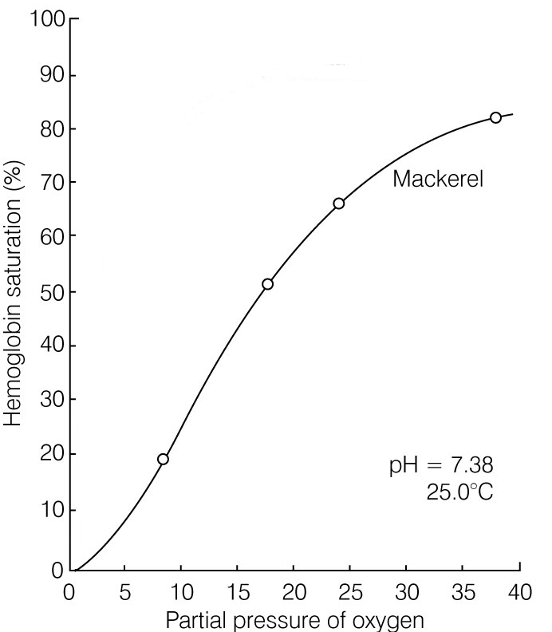

15. Sharks and tunas both cruise the open seas. Despite this commonality, these two fishes have very different body forms. Paul Webb, on pgs 80-81 of his Scientific American article, "Form and Function in Fish Swimming," explains why these two fishes differ so greatly. Describe the physiological, structural and ecological differences between sharks and tunas that explain the overall morphological difference in these cruising fishes. (15 pts)

16. Diagram and explain how a physoclistous bladder is inflated and emptied. Be sure to include all of the key structures and physiological processes. Indicate proper direction of flow for all molecules involved. Use representative values for pH and oxygen concentration to aid your explanation. (15 pts)

17. Explain how stenohaline freshwater and saltwater bony fishes maintain osmotic homeostasis. Explain for water and for relevant ions (e.g., Na⁺, Cl⁻, K⁺, Ca²⁺). Include for each when diffusion is operating and when active transport is required, and the primary regions for entry and exit of water and ions. Use illustrations to enhance your explanation. Do not include elasmobranchs or hagfishes. (15 pts)

